Module 02 Lab 02 Data Wrangling Laptop Pricing Screenshot Evidence and Discussion
Reference label for this notebook: Lab2 (each heading below is numbered Lab2_1, Lab2_2 and so on).
This document gathers the screenshots of Module 02 Lab 02, data wrangling on the laptop pricing dataset, and heads each one after the step it shows. The lab works on the prepared laptop file with 238 records and 16 columns and covers missing data, replacement with the mean and with the most frequent value, unit standardisation, binning and indicator variables. Each screenshot is captioned with its file name.

Lab2_1. Section 0 Importing the libraries and loading the dataset
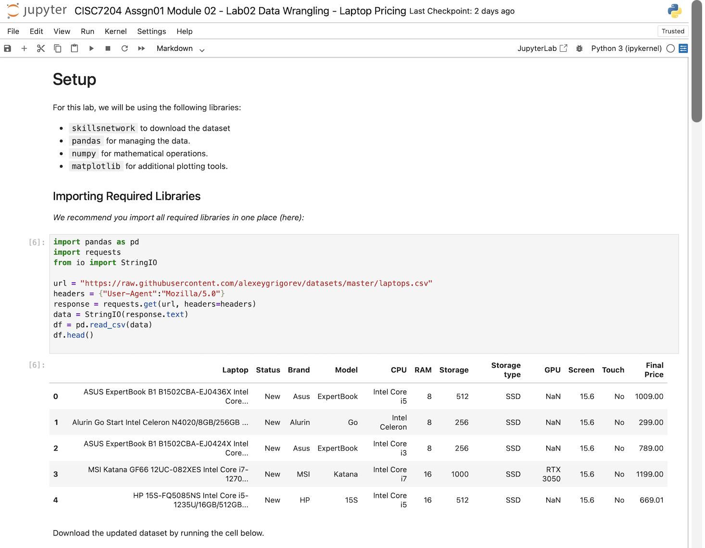
Screenshot file: `1_import_lib_load_laptop_dataset.png`.png
The first cell imports pandas and the other libraries used by the notebook and reads the laptop dataset into the dataframe.

Lab2_2. Section 0 Checking the structure of the dataset
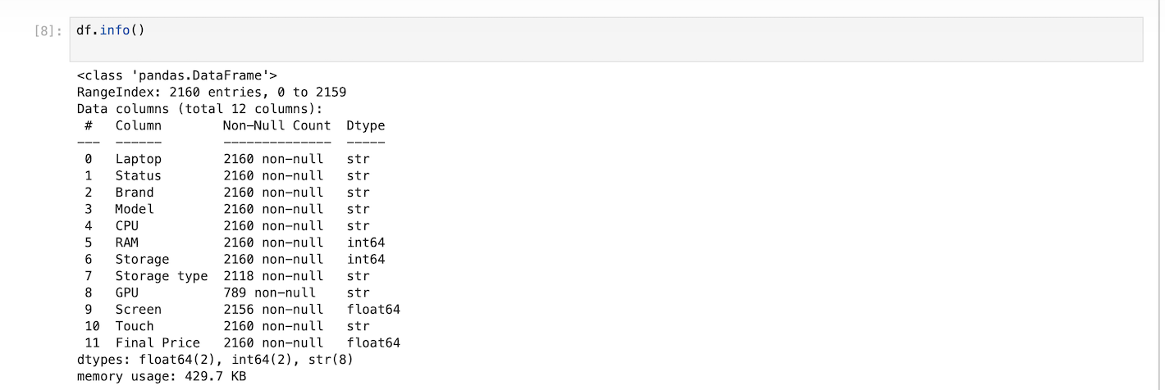
Screenshot file: `2_df_info_check_dataset_structure.png
df.info() is the first inspection of the loaded frame and shows the attribute list before any cleaning is applied.

Lab2_3. Section 1 Handling the missing storage type
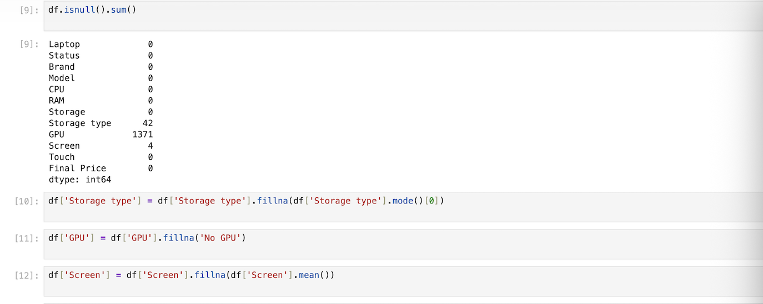
Screenshot file: 3_check_missing_values_and_fillna.png
The storage type column is filled with its most frequent value, which removes the missing entries before the modelling steps.

Lab2_4. Section 1 Downloading and loading the laptop dataset
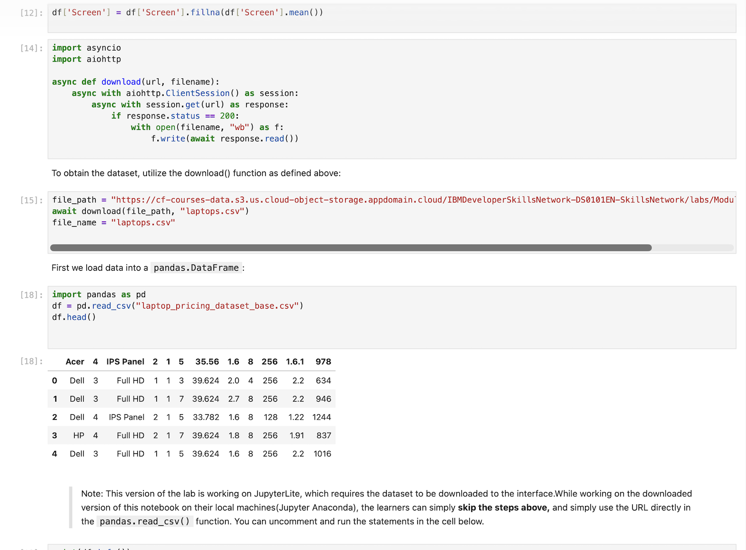
Screenshot file: 4_async_download_and_load_laptop_csv.png
The download helper brings laptop_pricing_dataset_mod2.csv into the working folder and the following cells read it into the dataframe.

Lab2_5. Section 1 Checking the dataset with df.info()
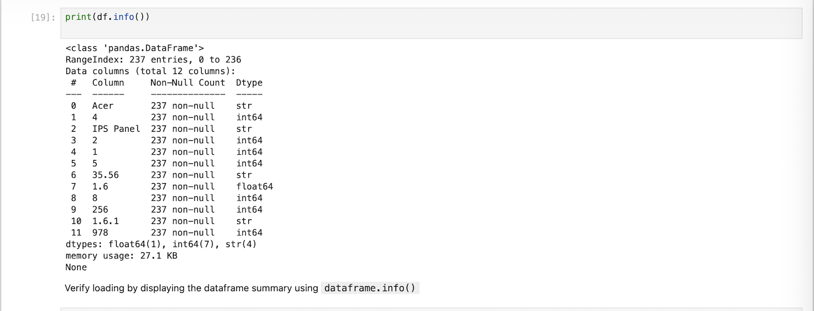
Screenshot file: 5_df_info_check_laptop_dataset_schema.png
df.info() lists the columns, the non null counts and the data types, so the missing attributes and the columns that still need work can be identified.

Lab2_6. Section 1 Previewing the rows and replacing the question marks
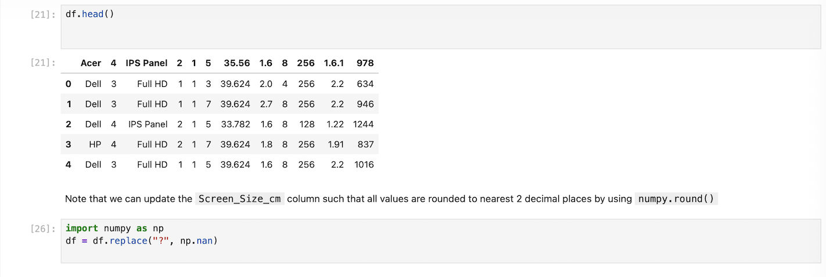
Screenshot file: 6_df_head_view_sample_and_replace_question_mark.png
The head of the frame is displayed and the round function is introduced for the Screen_Size_cm column, which is the preparation the tasks build on.

Lab2_7. Task 1 Identifying the missing data
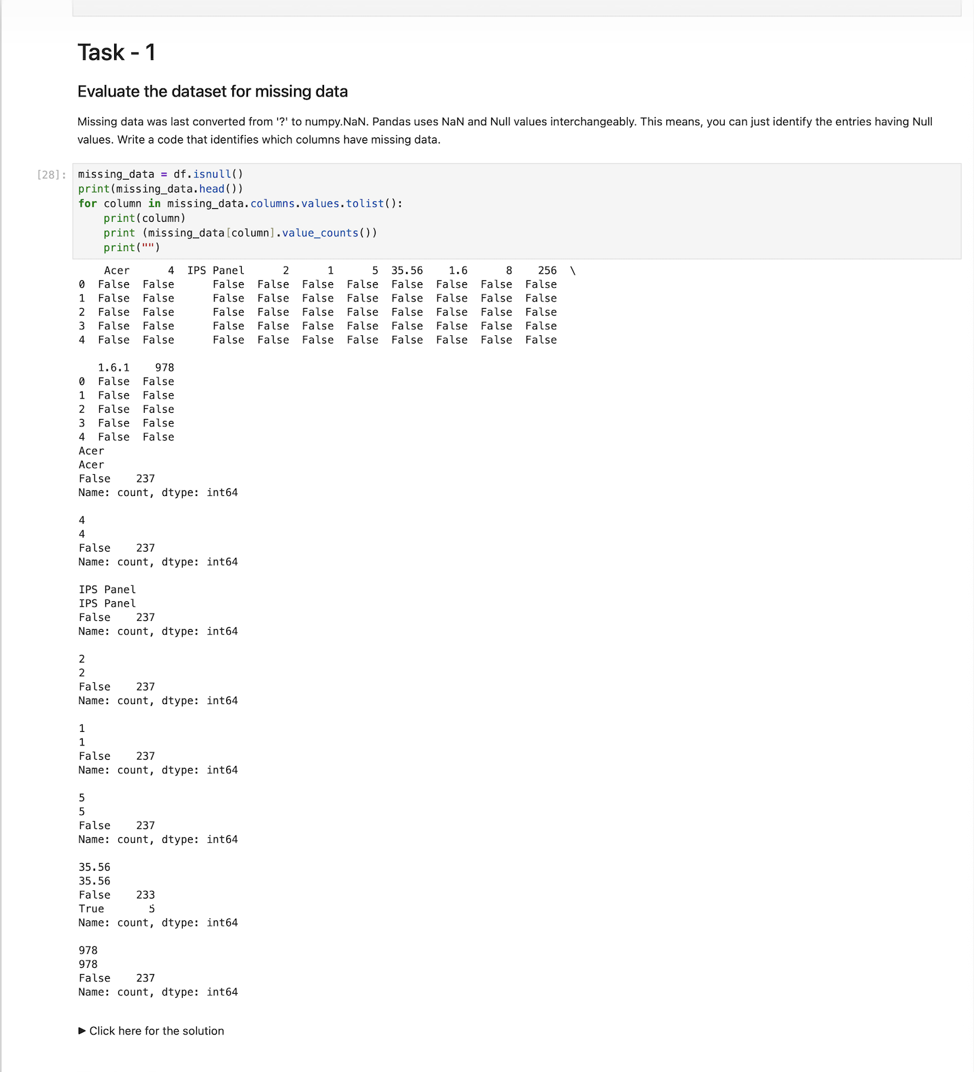
Screenshot file: Task-1.png
The dataset is evaluated for missing data, which is the prerequisite for choosing how each attribute is filled.

Lab2_8. Task 2 Replacing the missing continuous values with the mean
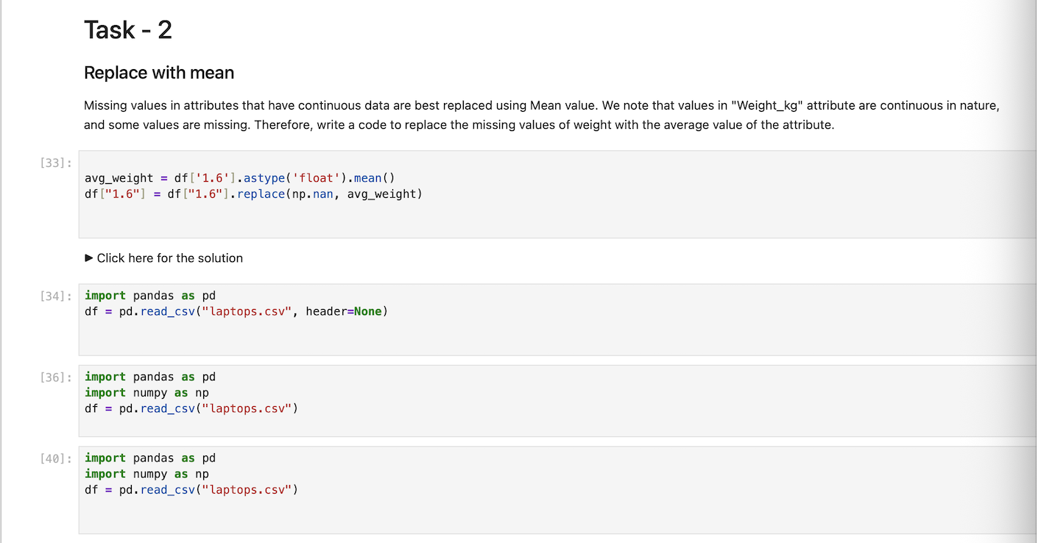
Screenshot file: Task2-1.png
The missing values of the continuous Weight_kg attribute are replaced with the mean of the column.

Lab2_9. Task 2 continued: replacing the missing categorical values

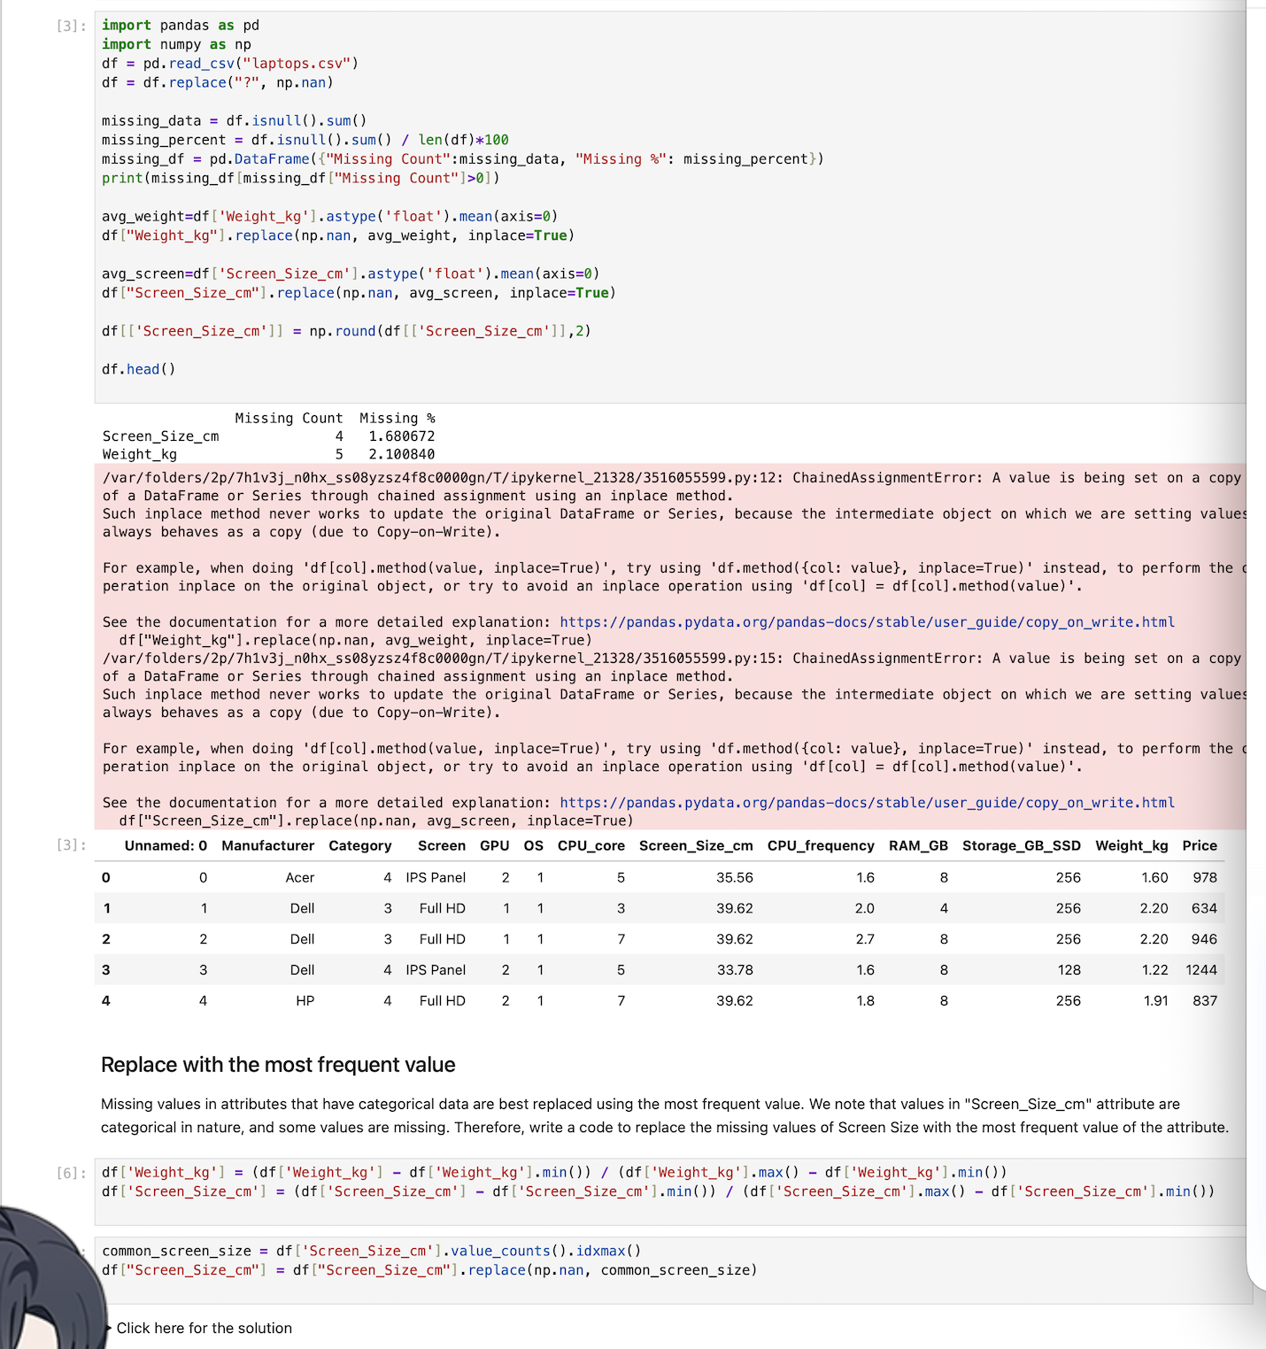
Screenshot file: Task2-2.png
The missing values of the categorical Screen_Size_cm attribute are replaced with its most frequent value.

Lab2_10. Task 4 Standardising the units of weight and screen size
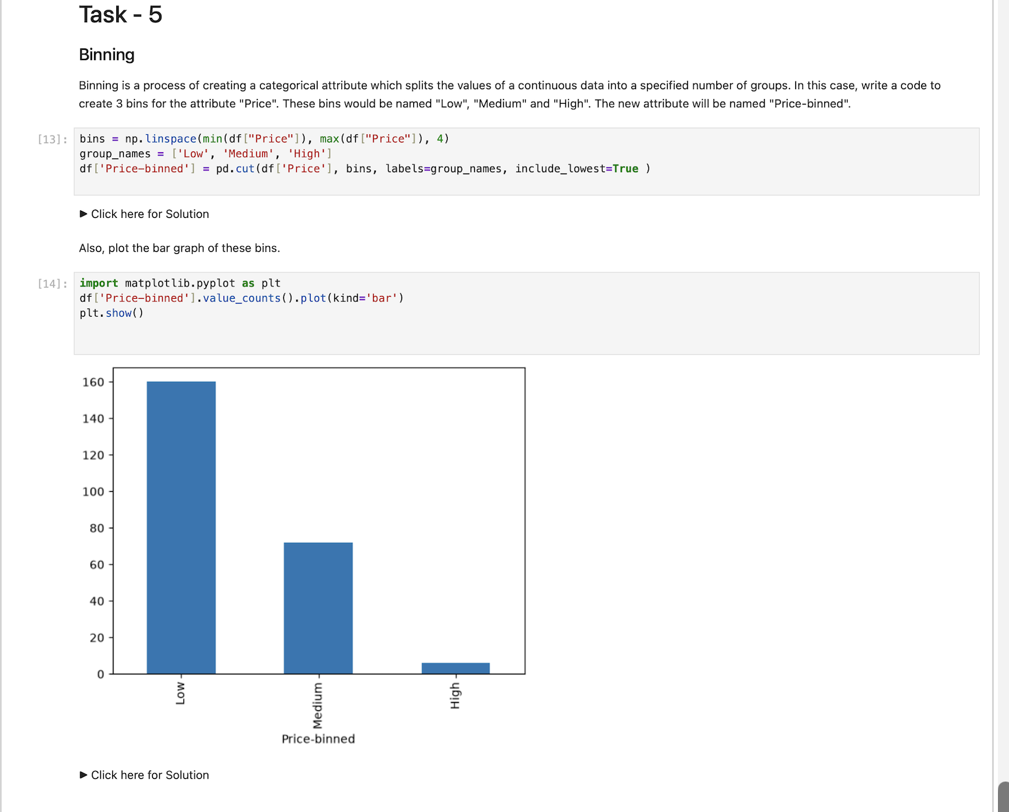
Screenshot file: Task3.png
Weight is converted from kilograms to pounds and screen size from centimetres to inches, with the columns renamed to match the new units.

Lab2_11. Task 4 continued: the conversion and rename code
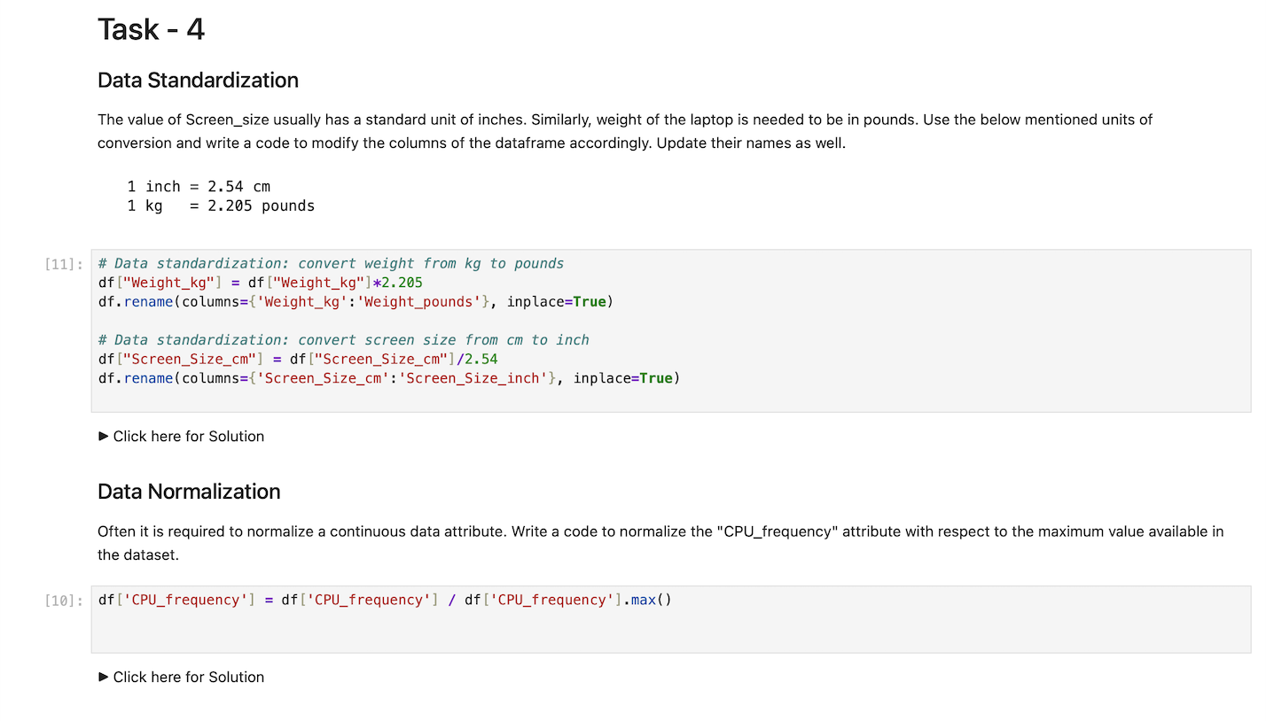
Screenshot file: Task4.png
The solution shows the multiplications and the rename calls that carry out the standardisation of the two attributes.

Lab2_12. Task 5 Binning the Price attribute into three groups
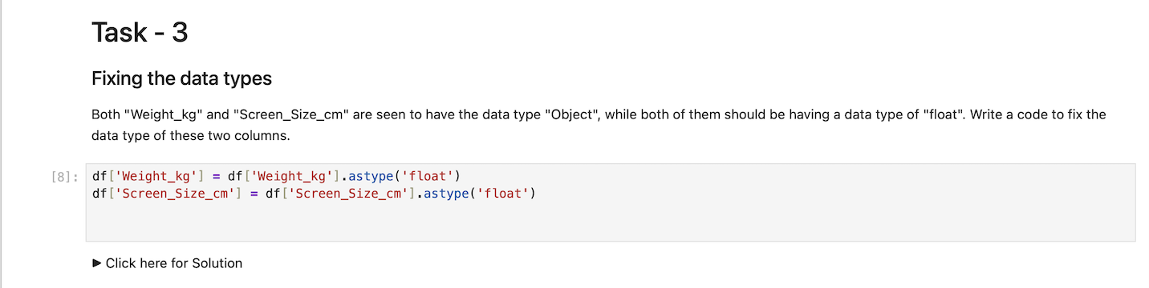
Screenshot file: Task5.png
Three bins with the labels Low, Medium and High are created from the Price column with pd.cut and stored in the new Price-binned attribute.

Lab2_13. Task 6 Creating the indicator variables for the screen type
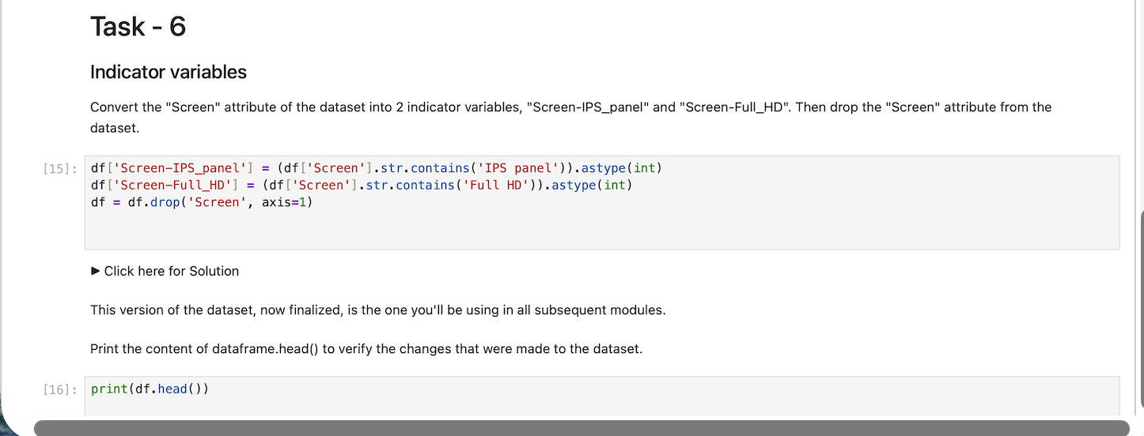
Screenshot file: Task6.png
The Screen attribute is converted into the two indicator variables Screen-IPS_panel and Screen-Full_HD and the original column is dropped.

